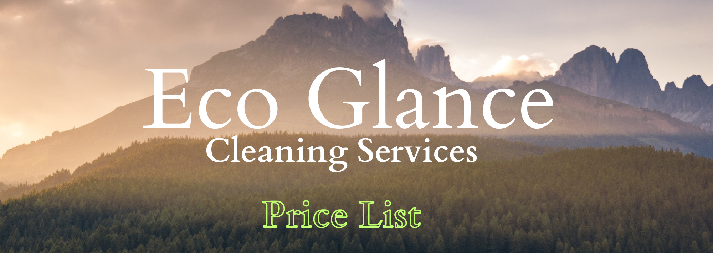
Welcome to Eco Glance Cleaning Services! We offer a range of eco-friendly cleaning solutions tailored to meet your needs. Our prices are competitive, and our commitment to quality is unmatched. Below is a detailed price list for our services.
Residential Cleaning
Service  Standard Cleaning  Regular Weekly  Before/After Special Events | Price  £19.99 per hour  £18.99 per hour  £20.99 per hour
AirBnB and Holiday Let
Service  Changeover Clean  Deep Cleaning  Providing Supplies and Laundry | Price  £20.99 per hour  £23.99 per hour  Contact for Quote
Deep Cleaning Services
Service  Residential Properties  Final Stage of Construction  End of Tenancy | Price  £20.99 per hour  £24.99 per hour  22.99 per hour
Eco-Friendly Guarantee
We use only environmentally friendly cleaning products that are safe for your family, pets, and the planet. Our commitment to sustainability ensures a healthier living and working environment.
Contact Us
Ready to schedule your cleaning service?
Easy Online Booking
Confirm your reservation by clicking the "BOOK NOW" button on website homepage. The easy process ensures a reliable booking experience. For inquiries, contact our support team anytime via the "Contact Us" section through email, phone, or WhatsApp. We are dedicated to delivering professional service at every step.
Phone: 07387477103 WhatsApp
Email: info@ecoglance-cleaning.com
Website: www.ecoglance-cleaning.com

